SANITY CHECK EDGES 2023
ii= 31
dir : R:\McKenzieLab\DANEHippocampalResponse\NE2h2 (Named NE2m3)\Novel Environment\NE2h2\NE2h2-220310-101531
points = pointsLE
binX = -500:.5:500;
binY = binX;
distan = totalEdgDist(kp,1) ;
[n,~,~,ix] = histcn(points,binX,binY);
kpp = all(ix>0,2);
mean_dist = accumarray(ix,distan,[],@nanmean,nan);
figure
imagesc(mean_dist)

Contexts :
'homecage'
'CB'
'homecage'
'WB'
'homecage'

I = 1 (homecage)
Kp : 1:11959
Before: 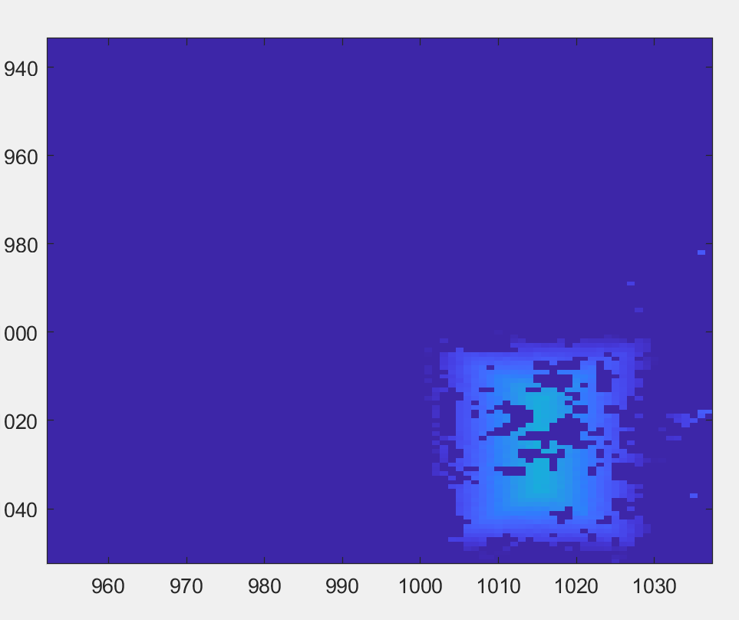
After:
Corrected context Transition kp = 35:11700;

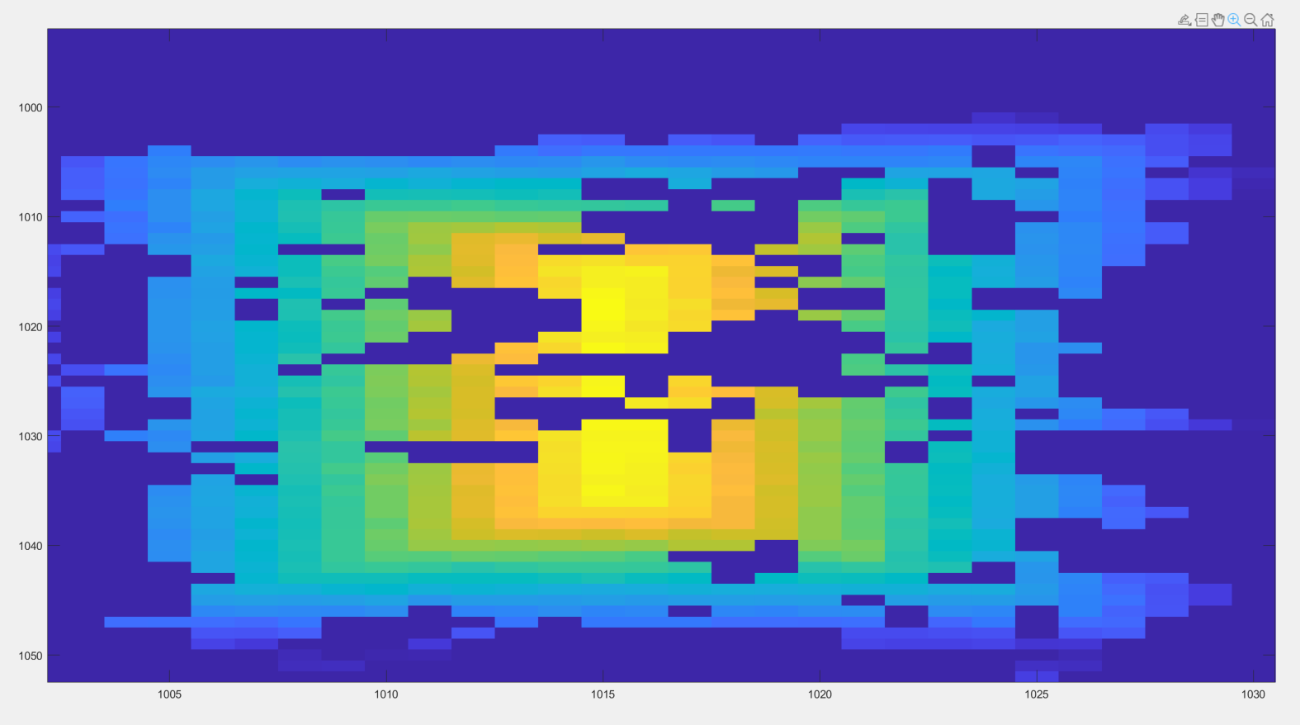

Before: (Check didn’t work?)
11960:25125
After:
11997: 23625
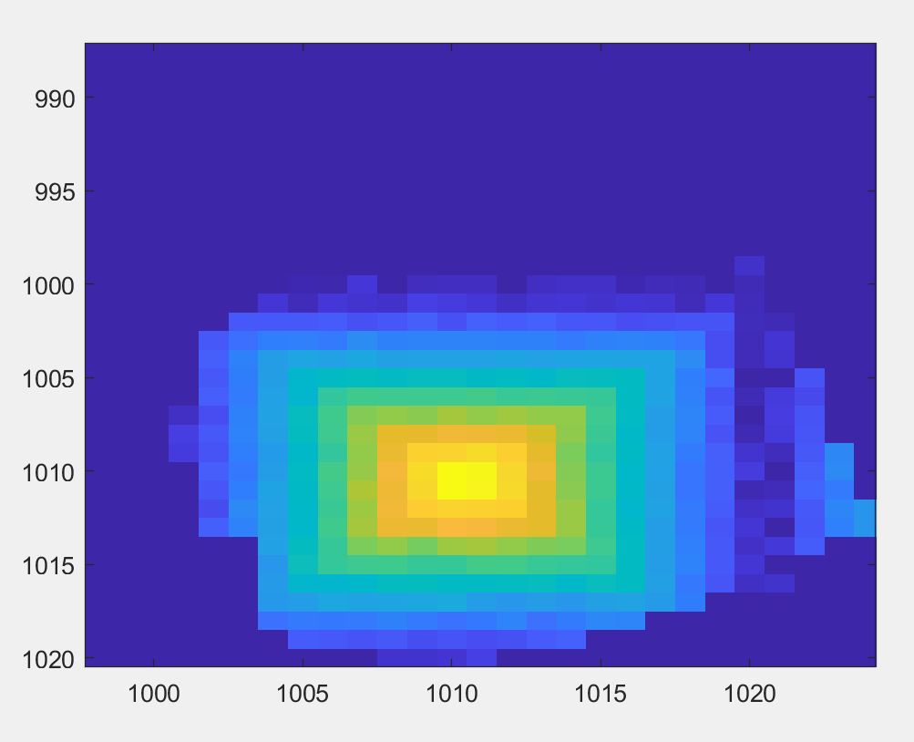

I = 3
Before: 25126: 45169
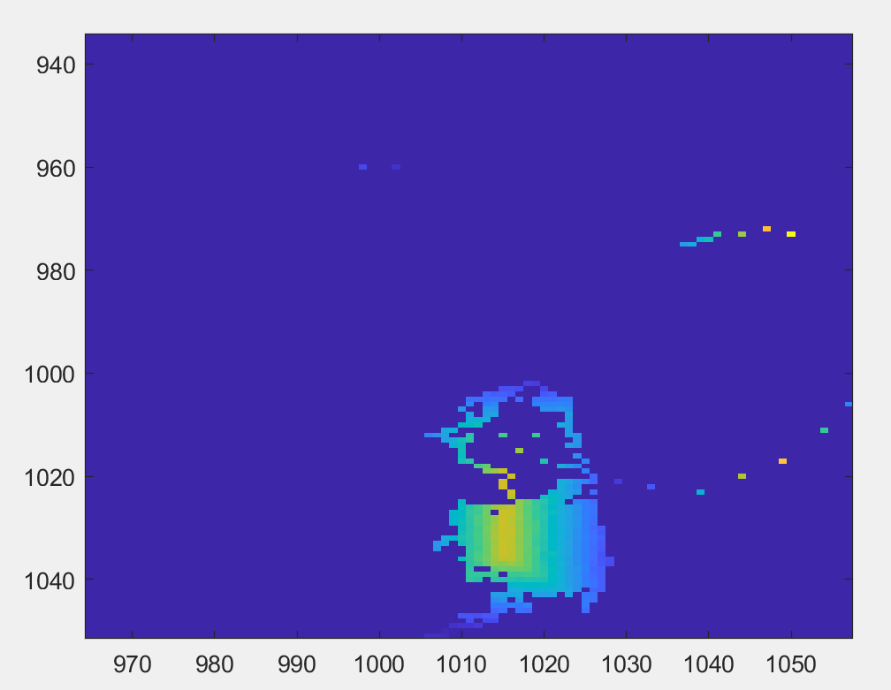

After: 25139: 45068

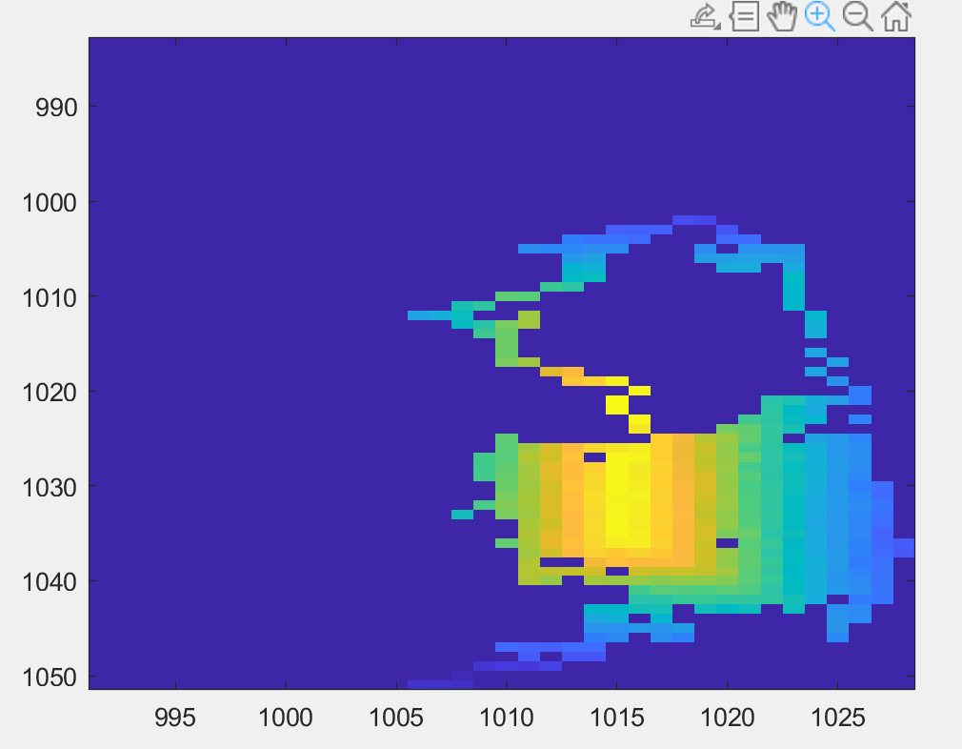

I = 4
Before: 45170:58189
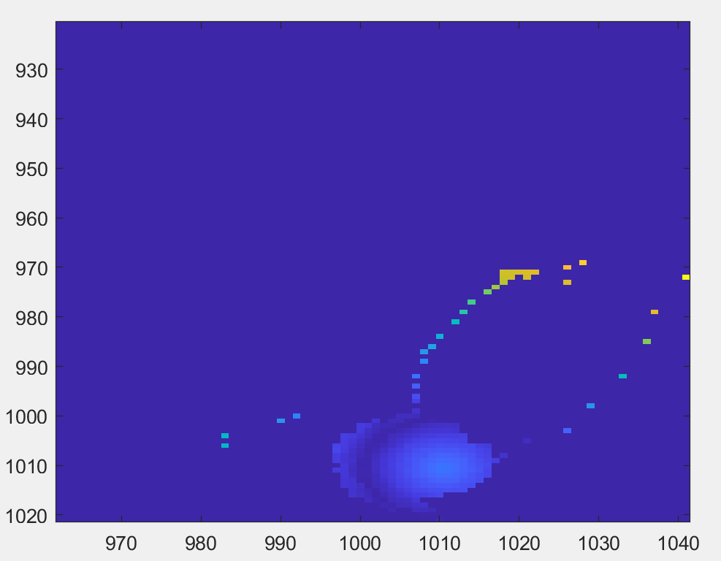

After: 45223:58141

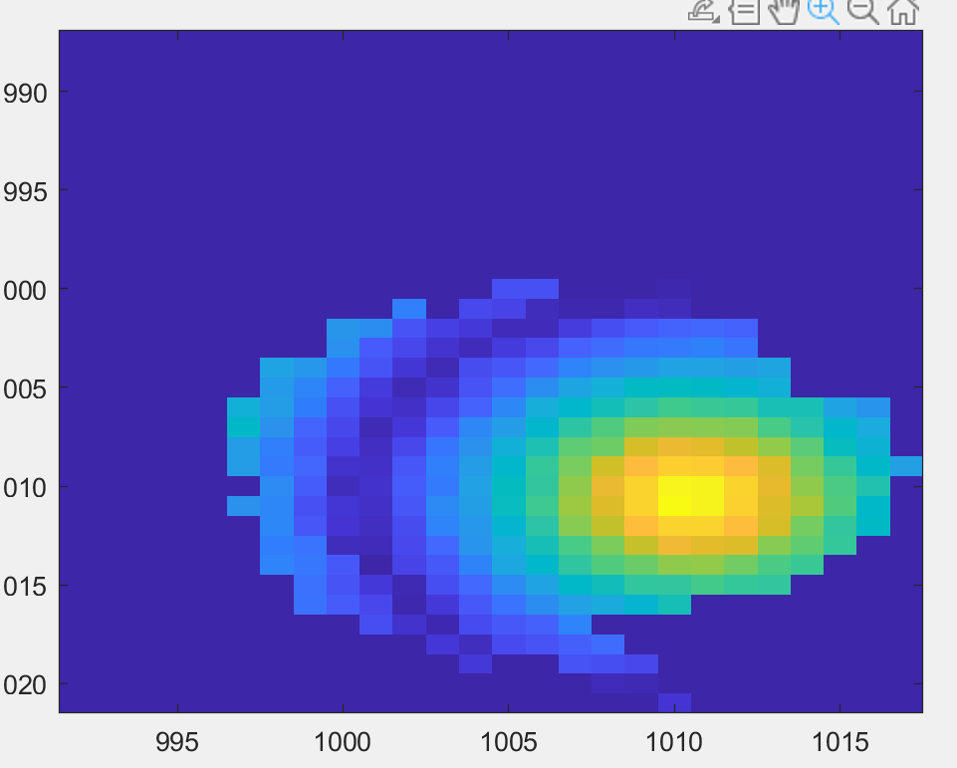

I = 5
